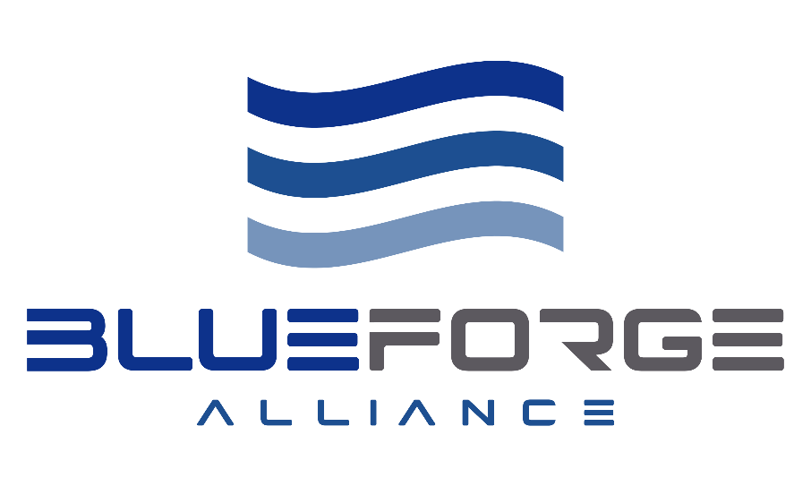
Request for Proposal

Project Description: | Program Security for DIVQ Vendors
RFP Number: | RFP-26-00006
RFP Issued Date: | 5/18/2026
Q&A Due Date: | 6/16/2026
Proposal Due Date: | 6/30/2026
Anticipated Commerciality: | Commercial
BFA Contract Vehicle: | BFA-Prime
Contract Type: | Firm Fixed Price
All RFPs will be submitted through the submission portal: | RFP-26-00006 Submission Form
For any Q&A Submit: | RFP-26-00006 Q&A Form
For General Inquiry: | Procurement@blueforgealliance.us

Table of Contents
Part I - Introduction 3
A. Background 3
B. Type of Solicitation 3
Part II - Instructions to Offerors 3
General Instructions: 3
Proposal Submission Instructions: 5
Part III - Proposal Structure and Contents 6
Volume 1: Proposal Cover Letter 6
Volume 2: Technical 7
2.1 Organizational Capabilities 7
2.2 Technical Approach 7
Volume 3: Cost/Price 9
3.1 Fixed Price or T&M: 9
Volume 4: Administrative 10
4.1 Standard Procurement Forms: 11
4.2 Ts & Cs : Flowdowns 12
4.3 Past Performance 12
4.4 Management Approach 12
Volume 5: Risk 13
Part IV – Evaluation Procedures 14
Part V - References 17

Part I - Introduction

Background
BlueForge Alliance (BFA) is a registered not-for-profit organization formed to support the U.S. Navy’s Submarine Industrial Base (SIB) and Maritime Industrial Base (MIB). BFA partners with the Navy and members of its more than 16,000 suppliers serving as a convening, technical and contracting partner, bringing together the best resources in the nation to recapitalize this nation’s sea-based deterrence and warfighting capabilities.

In support of this mission, BFA hereby issues this Request for Proposal (RFP) to Third Party Assessment Certification (C3PAO) industry partners to provide uplift and certification to CMMC 2.0 Level 2 accreditation for up to (75) Australian DIVQ Suppliers. Further details are described in Part III.

Type of Solicitation
The purpose of this Request for Proposal (RFP) is to solicit proposals from qualified Offerors to execute the requirements outlined in this document. BFA intends to award one or multiple subcontracts to the selected Offeror(s) whose proposal(s) represent(s) the best value based on the evaluation criteria detailed in Part IV. All eligible and interested Offerors are encouraged to carefully review these requirements and submit a complete response in accordance with the instructions provided herein.

Part II - Instructions to Offerors

General Instructions:
- Offerors are encouraged to direct questions to the Q&A Form identified on the RFP cover page. BFA will consider questions received by the 16 June 2026 Q&A due date specified on the cover page of this RFP. Questions not received by the due date may not receive a response. To ensure parity amongst Offerors, relevant questions and BFA responses will be provided to the entire pool of prospective Offerors via regular updates on the BFA RFP website. It is the responsibility of the Offerors to check the website for updated questions and answers.
- This RFP is not intended, nor shall it be construed to: 1) authorize the procurement of any materials or services; and 2) obligate BFA to make an award to any Offeror.
- Upon receiving and evaluating proposals, BFA may elect to award a subcontract to a single Offeror, multiple Offerors, or no Offerors, as deemed by BFA to be in the best interest of BFA and the Navy. Unsuccessful Offerors will be notified accordingly.
- Neither BFA nor the Government will reimburse the Offeror for any expenses incurred in responding to this RFP. All costs associated with preparing and submitting a proposal shall be the sole responsibility of the Offeror.
- Proprietary information received in response to this RFP will be safeguarded in accordance with Government regulations. Information submitted will not be returned.
- The Offeror is solely responsible for properly marking and clearly identifying any proprietary information or trade secrets contained within their response. BFA will not be liable for, or pay any consequential damages stemming from, the release of any proprietary information not properly marked and clearly identified.
- Various elements of this RFP are driven by the contract type, commerciality, the prime contract under which BFA will be making the award. The cover page of this RFP provides these specifications. Should the Offeror have a conflicting perspective over which items are applicable, the Offeror is encouraged to promptly seek guidance from the BFA POC identified on the RFP cover page.
- Any subcontract(s) resulting from this RFP will be subject to the terms, conditions, and forms (collectively referred to as “forms”) contained on the BFA Partner With Us (www.blueforgealliance.us/partner-with-us) page. These forms are updated from time to time, and the latest version found on the “Partner With Us” page will form the basis for the resulting subcontract. Proposal Volume 4.1 contains the forms that need to be completed and submitted by the Offeror with their proposal in accordance with the instructions contained in Volume 4. Section 4.2 includes the Terms and Conditions (Ts & Cs), clause flowdowns, and insurance requirements. By submitting a proposal, the Offeror agrees to be bound by the applicable Ts & Cs. Should the Offeror have any questions or requested revisions to these Ts & Cs, they shall be submitted via the Q&A process above. If approved, the revisions will be offered to all prospective Offerors. Requests for revisions submitted after the Q&A process has closed will not be considered, out of fairness to all Offerors.
- By submitting a proposal, the Offeror affirms that it has no actual or perceived conflicts of interest, including organizational conflicts of interest (OCIs), that would impact its ability to perform under this subcontract in accordance with the U.S. Government’s Federal Acquisition Regulation (FAR) Subpart 9.5. Further, the Offeror agrees to promptly notify BFA if any such conflict arises during performance.
- Offerors are advised that BFA support Contractors may assist in the evaluation of proposals. These individuals are bound by appropriate non-disclosure agreements and are prohibited from disclosing any proposal information or using it for any purpose other than assisting in the evaluation process. By submitting a proposal, the Offeror consents to the release of its proposal to such personnel for these purposes.
- All respondents must be registered in the System for Award Management (SAM) and have a valid Unique Entity ID (UEI) number. Respondents must maintain an active registration in SAM.gov with current information at all times during which a proposal is under consideration or have a current award with BFA. Please note that new registrations take an average of 7-10 business days to process; additional information is available at SAM.gov.

Proposal Submission Instructions:
- Proposals must be submitted no later than 1700 CDT on 30 June 2026.
- BFA intends to notify suppliers of decisions during the week of 3-7 August 2026.
- Proposals must be submitted via Submission portal RFP-26-00006 Submission Form and can be found at this website: Partner With Us | BlueForge Alliance.
- All Q&A submissions will use the RFP-26-00006 Q&A Form. Weekly updates will be posted on Fridays and all Q&A submissions are due 16 July 2026.
- The proposal must be on company letterhead, dated, and signed by an authorized representative of the company.
- Proposals are requested to be formatted on 8.5 x 11-inch paper with 1-inch margins on all sides.
- Text should be typed in a minimum 10-point font, using Times New Roman typeface.
- Line spacing is requested to be single-spaced or greater, and any text within charts, tables, footnotes, or graphics must not be smaller than 8-point font for legibility.
- Proposals should be clear, concise, and include sufficient detail to facilitate BFA’s effective evaluation of the proposal.
- Proposals shall not include any Classified or Controlled Unclassified Information (CUI) unless pre-coordinated and authorized in writing by BFA.
- The Offeror may submit separate files for each proposal Volume and sub-Volume, or present the proposal in a more consolidated format, provided the content is logically organized and easily navigable.
- BFA POC can be reached at procurement@blueforgealliance.us.

Part III - Proposal Structure and Contents
The proposal will consist of the following five Volumes: 1) Proposal Cover Letter; 2) Technical; 3) Cost/Price; 4) Administrative and 5) Risk. Submission requirements for each Volume are further detailed in the following sub-Sections.
Proposals are subject to the page limitations outlined below and any pages exceeding the stated limit may not be reviewed or considered in the evaluation.

Table 1
Volume | Description | Page Limit
1 | Proposal Cover Letter | Unlimited
2 | Technical | Unlimited
3 | Cost/Price | Unlimited
4 | Administrative | Unlimited
5 | Risk | Unlimited

Volume 1: Proposal Cover Letter
The proposal cover letter should include the following:
- Project Title: Identify project title
- RFP Number: Located on page one.
- Submission Date: Include proposal submission date
- Offeror POC Information: Name, address, and contact information for person(s) authorized to conduct negotiations and commit the Offeror. If applicable, provide POCs for Contractual, Financial, and Technical matters
- NAICS Code: Identify Offeror’s primary NAICS code
- DUNS #: Include DUNS number
- CAGE Code: Include CAGE code
- Unique Entity Identifier (UEI): Include UEI number
- Type of Organization: Large Business, Small Business, SDVOSB, etc.
- Work Location: Provide physical address for the location/division proposed to perform the work
- Programs Supported: Identify program(s) supported by effort (e.g. CLB, VCS, Other)
- Security Classification: Identify security classification associated with proposal (e.g. Unclassified, CUI, Classified)
- Period of Performance: Include the anticipated period of performance, in months, for the Statement of Work (SOW). If there are Options, include the associated period of performance for such Options.
- Proposed Award Amount: Include the anticipated total award amount for the SOW
- Confidentiality Statement: If applicable, please provide a confidentiality statement
- Assumptions: It is requested that the Offeror note any assumptions or conditions relevant to their proposal, if applicable. Offerors may include assumptions or conditions; however, no assumptions or conditions will supersede the SOW or Ts & Cs.
- Proposal Validity: The minimum proposal validity period of no less than 120 days. If your proposal does not specify a validity period or date, BFA will assume your proposal is valid in accordance with the minimum period above.

Volume 2: Technical

2.1 Organizational Capabilities
This Offeror should describe its organizational technical and financial capabilities to perform the work required under this contract. This Section should include:
- General overview of your business, relevant experience, technical and financial capabilities and major marketspace accomplishments (with a particular focus on accomplishments that directly support the SIB/MIB).
- Qualifications and availability of key personnel, including relevant technical and management experience.
- Identify any specialized skills or expertise necessary to execute the project and how your organization intends to source it.

2.2 Technical Approach
The AUKUS Defence Industry Vendor Qualification (DIVQ) program aims to qualify and integrate Australian suppliers in the Virginia Class Submarine (VCS) supply chain. The program provides a pathway for Australian suppliers to meet U.S. Navy manufacturing standards in collaboration with Australian Submarine Corporation (ASC), General Dynamics Electric Boat (GDEB) and Huntington Ingalls Industries Newport News Shipbuilding (HII-NNS). DIVQ enhances existing and future U.S. submarine programs and sovereign Australian submarine building by increasing Australian Submarine Industrial Base (ASIB) capability, capacity, and resilience.
Out of the 75 Australian suppliers participating in DIVQ, some will require uplift in the form of implementation for Cybersecurity Maturity Model Certification (CMMC) compliance. Following CMMC Assessment Process (CAP), subcontractors that perform implementation for a supplier cannot be the assessors for that same supplier’s CMMC certification. C3PAOs that are selected to perform a supplier’s CMMC assessment for certification cannot be the providers of implementation needed for that supplier’s assessment readiness. The subcontractors submitting proposals need to include the relative documentation applicable to what services they can provide within this process.
All proposals must include:
- Detailed description of the process and methodology for uplifting or certifying suppliers to CMMC Model 2.0 that meets the requirements of FAR 52.204-21 (15 requirements aligned with Level 1) and NIST SP 800-171 REV 2 (110 requirements aligned with Level 2). This must cover the 14 domains within the CMMC Model that are specified in NIST SP 800-171 REV 2. This should include the offeror’s understanding of the technical requirements, objectives, and constraints of the effort.
- State which part(s) of the CAP the subcontractor has interest in supporting.
- Experience, skills and capabilities related to the CMMC ecosystem and provide organizational structure with key personnel.
- Where the subcontractor is located and if they can support travel to the selected supplier’s site with adherence to relevant regulations.
- Willingness to cooperate with all other subcontractors that may be selected to support this effort.
- Subcontractors that are bidding on supplier implementation uplift should provide which C3PAOs have assessed and certified their CMMC implementation of suppliers in the past. More details of this requirement are outlined in Volume 2.3 (Past Performance).
- Approach to evaluating current supplier security readiness and maturity. Risk management and mitigation strategies.
- A description of approach to ensure quality throughout contract performance, to include any quality control plans, processes for identifying and correcting deficiencies, and methods for continuous improvement.
- Plan for supporting suppliers in Identifying, developing and maintaining System Security Plans (SSPs) and Plan of Actions and Milestones (POA&Ms).
- Monthly Status Report Inputs that include supporting documentation, Summary of work completed, Site Visit Support Documentation with records of meetings, audits, and findings.
- Project Closeout Documentation summarizing final status and lessons learned.
- Compliance Documentation demonstrating adherence to ITAR, NDP-1, CUI, and other relevant regulations.
This information shall be provided using the Statement of Work Template (SOW) Template and part of Volume 2 submission.
SOW RFP Submission Template
  - Demonstrated Performance in the Market
The Offeror must provide comprehensive evidence of their performance in the market, specifically addressing the scope and scale of efforts similar to those required under this solicitation. The submission should include:
- Scope and Scale of Similar Projects: Describe previous projects or contracts that are comparable in size, complexity, and subject matter to the current requirement. Include details such as project objectives, deliverables, timelines, and outcomes.
- Quantitative Metrics: Provide quantitative data to illustrate the scale of past efforts (e.g., contract values, number of units delivered, geographic coverage, duration of engagement, number of personnel involved).
- Relevant Experience with the Australian Defense Supply Chain: Clearly indicate the extent of your experience working with the Australian Defense supply chain. Specify the nature of your involvement, types of products or services provided, and any partnerships or collaborations with Australian Defense entities.
- Client References and Testimonials: Include references from previous clients, particularly those within the Australian Defense sector, to validate your performance and reliability.
- Lessons Learned and Best Practices: Summarize key lessons learned from prior engagements and describe how these will inform your approach to this project.
- Supporting Documentation: Attach supporting documents such as performance reports, awards, certifications, or letters of commendation relevant to your market performance and experience.
All information should be organized and presented in Volume 2.3 of your proposal.
  - Project Management Approach
The Offeror must provide a comprehensive description of their overall project management approach for fulfilling the required capability. The submission should include:
- Project Management Methodology: Describe the project management framework or methodology to be used (e.g., PMBOK, Agile, PRINCE2), including how it will be tailored to meet the specific needs of this project.
- Organizational Structure and Roles: Present the proposed project team structure, including key roles and responsibilities. Provide an organizational chart and brief bios of key personnel.
- Work Breakdown Structure and Schedule: Outline the major tasks and milestones, including a Work Breakdown Structure (WBS) and a high-level project schedule or Gantt chart. Indicate critical path activities and dependencies.
All information should be organized and presented in Volume 2.4 of your proposal.

Volume 3: Cost/Price
Offeror must provide cost and pricing data information electronically using Microsoft Office 2016 (or more current) version of Word and Excel, if applicable. The following table indicates which requirements are applicable to this effort based on the procurement specific specifications noted on the RFP cover page. Provide this as part of Volume 3 submission.
Table 2
Section | Applicable | Criteria
3.1 | ☒Yes | ☐ No | Firm Fixed Price (FFP) or Time & Materials (T&M)
3.2 | ☐Yes | ☒ No | Cost Type

3.1 Fixed Price or T&M:
It is BFA’s intent to obtain the type and quantity of data necessary to establish a fair and reasonable price, but not more data than is necessary. Complete the Cost Basis of estimate worksheet below so it aligns to the SOW. Offerors must populate the price associated with each line item (or fully burdened T&M rates for each labor category, if applicable), revising the table format, if necessary. Offerors may, but are not required to, provide a narrative in support of proposals developed in accordance with the instructions in this Section (3.1).
Cost Basis of Estimate Worksheet

If BFA is unable to determine whether the proposed pricing is fair and reasonable, additional data may be requested.
For FFP efforts, Offerors may include a planned milestone invoice schedule to facilitate payments during performance. A planned milestone invoice schedule is only applicable to FFP efforts, as payments under Cost Type or T&M contract types will be paid as costs are incurred in accordance with BFA’s Ts and Cs. The planned milestone invoice schedule is intended to provide BFA with the anticipated invoice plan needed to execute the SOW. The planned milestone invoice schedule must be tied to the specific deliverables and milestones identified in the SOW. The proposed invoice schedule should include:
  - Invoice ID
  - Invoice Amount
  - Associated Performance Milestone/Deliverable/Acceptance Criteria
  - Anticipated Invoice Submission Date
BFA reserves the right to request a Certificate of Current Cost or Pricing Data in accordance with FAR 15.403 & 15.406-2, prior to award, for proposals over $2M if it is determined that adequate competition does not exist.

Volume 4: Administrative
The Administrative Volume includes: 1) BFA standard procurement forms the Offeror will need to complete, as applicable; and 2) procurement specific Ts & Cs the RFP deems applicable. The tables below outline the forms and Ts & Cs that must be reviewed, completed, and/or concurred with, as applicable 3) Past Performance in the market and 4) management approach. These artifacts are all found on the BFA website on the “Partner with Us” page and are also linked, below. In any event, the latest version found on the “Partner with Us” page will be the version used.

4.1 Standard Procurement Forms:
Table 3 contains the standard forms that must be completed in Volume 4.1 with every proposal submission, as applicable.
Table 3
Volume 4.1 – Standard Procurement Forms
Item | Document | Applicability | Submission Requirement
4.1.1 | BFA Supplier Information Form | All Proposals | Completed and signed form to be included as part of Volume 4.1
4.1.2 | BFA Cost Accounting Standards | All Proposals | Completed and signed form to be included as part of Volume 4.1
4.1.3 | BFA Representations and Certifications | All Proposals | Completed and signed form to be included as part of Volume 4.1
4.1.4 | BFA CUI Handling Assessment and Certification | All Proposals | Completed and signed form to be included as part of Volume 4.1
4.1.5 | BFA Supplier Assertion of Commerciality | All Proposals | Completed and signed form to be included as part of Volume 4.1
4.1.6 | BFA Notification of Limited Rights | All Proposals | Completed and signed form to be included as part of Volume 4.1
4.1.7 | Small Business Subcontracting Plan | For non-commercial product or non-commercial service to other than Small Business (i.e. a Large Business), >$750K, and opportunities for further subcontracting exist. Submit IAW FAR 52.219-9 | Completed and signed form to be included as part of Volume 4.1
4.1.8 | Supplier Conflict Of Interest Form | All Proposals | Completed and signed form to be included as part of Volume 4.1
4.1.9 | BFA Vendor Information Request Form | All Proposals | Completed and signed form to be included as part of Volume 4.1
4.1.10 | W9 or W8 | All Proposals | Completed and signed form to be included as part of Volume 4.1
4.1.11 | Certificate of Insurance | All Proposals | Completed and signed form to be included as part of Volume 4.1

4.2 Ts & Cs : Flowdowns
- Provide a detailed review of the Terms and Conditions within Table 4 in Volume 4.2 and provide concurrence or redlines with proposal submittal as part of Volume 4 submission.

Table 4
Volume 4.2 Terms and Conditions
Item | Document | Applicability | Submission Requirement
4.2.1 | BFA General PO Terms and Conditions | All Proposals | Completed and reviewed to be included as part of Volume 4.2
4.2.2 | BFA Prime Insurance Requirements | All Proposals | Completed and reviewed to be included as part of Volume 4.2
 | Domestic Supplier Commercial Flowdowns:
4.2.3 | BFA Prime Commercial Flowdowns | All Proposals – Domestic Suppliers | Completed and reviewed to be included as part of Volume 4.2
 | International Supplier Commercial Flowdowns:
4.2.4 | BFA Prime Commercial SEA02 Commercial Flowdowns- Non-US Supplier, Not Recruit US | All Proposals - International suppliers - Non US Non recruit | Completed and reviewed to be included as part of Volume 4.2
4.2.5 | BFA Prime Commercial SEA02 Commercial Flowdowns- Non-US Supplier, Recruit US | All Proposals – International Suppliers - Non US Recruit | Completed and reviewed to be included as part of Volume 4.2
*If links above are not working, Please visit BlueForge Alliance - Partner With Us to review our Flowdowns and Terms & Conditions.

Volume 5: Risk
  - Risk Management
The Risk Management BFA is requesting pertains to the proposal itself, focusing on the technical content (scope) of the project, the total project budget, and the project schedule.
BFA employs a proactive and structured risk management methodology to ensure program objectives are achieved efficiently and effectively.
Risk Management can be performed through various methodologies; however, most of them contain some basic principles:
- Risk Identification,
- Risk Assessment (evaluation of the scenario, its likelihood of occurrence, and its negative impact or consequence),
- Risk Mitigation(s),
- Risk Monitoring,
- Risk Communication (part of steps 1-4),
- Cycling back through steps 1-5, as risks continuously change and risk assessments are only snapshots in time
The risk assessment should be conducted with the aid of a scorecard.
Risk Assessment Scorecard

The typical Risk Matrix, within the BFA scorecard, is an evenly weighed 5x5 (LxC) with L = Likelihood and C = Consequence (or Impact)
Please refer to basic BFA scorecard below for guidance:
BFA Risk Scorecard:
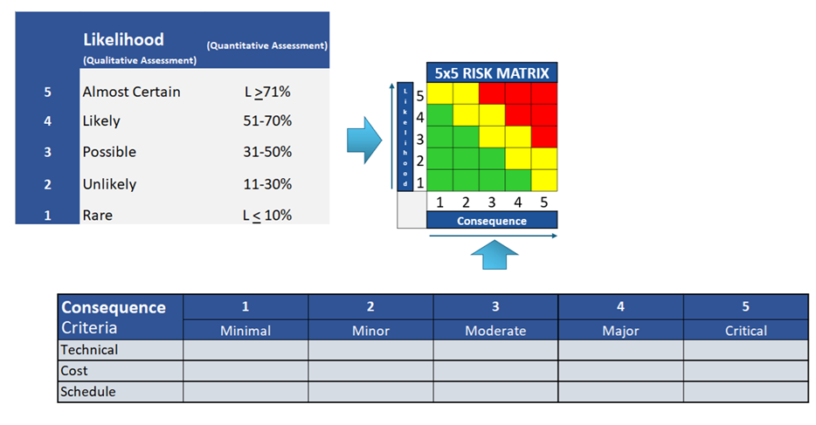
The consequence levels are most commonly qualitative in nature (Minimal through Critical) and their boundaries will be left open to fit the proposal objectives.

The risk assessment must include:
- Identification of key risks related to project objectives, deliverables, and requirements (provide risk statements).
- Documentation of assumptions and dependencies relevant to risk assessment (include key risk factors).
- Assessment of each risk’s Likelihood and potential impact (Consequence), with the respective LxC score.
- Proposed mitigation strategies for each identified risk.
- Contingency plans for high-priority risks (to minimize the impact severity once those risks are realized).
- Approach for stakeholder communication regarding risk management.
Risk management activities are documented and reviewed regularly to support informed decision-making. Our methodology integrates risk management into project planning, execution, and closure, fostering a culture of accountability and resilience. By anticipating and addressing risks, BFA aims to minimize disruptions and maximize the probability of successful outcomes. Respondents are expected to align their risk assessment practices with BFA’s standards and provide a comprehensive initial risk assessment as part of their proposal.

Respondents must include an initial proposal risk assessment in their submission. The risk assessment should address risks associated with meeting the stated objectives and completing the deliverables against the requirements outlined in this RFP. Offerors shall use the Risk Assessment Scorecard, at a minimal, for this submission.

All information should be organized and presented in Volume 5.1 of your proposal.

Part IV – Evaluation Procedures
BFA will evaluate all proposals in response to this RFP using an impartial, equitable, and comprehensive evaluation process to select the source (or sources) whose proposal(s) is/are determined to be the most advantageous to BFA's mission objectives and the interests of the SIB/MIB. Proposals will be evaluated on their own individual merit but may be compared to each other for purposes of prioritization and selection. BFA reserves the right, at its sole discretion, to engage in negotiations with all, some, or none of the Offerors.
A summary of the Evaluation weights are as follows:
Table 5
Technical | 50%
Cost/Price | 20%
Administration | 10%
Risk | 20%
Technical:
The Technical portion of the RFP will be evaluated across three categories. The Technical Approach (2.2) will account for 30% of the total technical score, while Performance in the Market (2.3) will account for 10%, and Project Management Approach (2.4) will account for 10%. Together, these categories comprise 50% of the total evaluation score.
Each category will be assessed on a scale of up to 100 points, with the final technical score determined using the following weighted criteria:
Technical Approach Requirements:
- Alignment of Technical Approach with RFP technical requirements (40 pts)
  - How directly and comprehensively does the proposal address the RFP technical requirements by detailing how it will provide the services and products being sought by the RFP? (20 pts)
  - How well does the proposal define its CMMC assessment process to ensure that each supplier who participates will have access to a Registered Practitioner (RP) and/or Registered Practitioner Organization (RPO) to:
    - have/generate a System Security Plan (SSP);
    - prepare to be assessed for its implementation of each of the 110 security controls contained in NIST SP 800-171 REV 2;
    - have/generate a POAM for those security controls that are not implemented;
    - achieve the required NIST SP 800-171 REV 2 assessment score and address all POAM items to be connected to a C3PAO for Level 2 assessment and certification? (20 pts)
- Flexibility of technical approach to enable provision of CMMC uplift services to companies with a diverse range of digital and cybersecurity sophistication (30 points)
  - How well does the proposal define a technical approach that can be applied to companies with varying degrees of sophistication in both their digital infrastructure, as well as their cybersecurity posture? (10 pts)
  - How well can the approach apply to small, medium, and large companies? (10 pts)
  - How scalable is the approach to ensure that it can meet the RFP requirement to serve 75 DIVQ suppliers? (10 pts)
- Strength of proposal team (30 pts)
  - How strong is the team identified in the proposal with respect to possessing the expertise and experience needed to achieve all aspects of the technical requirements defined in the RFP? (20 pts)
  - What is the strength of the proposal team with respect to including a path for suppliers to be able keep / renew their CMMC certification once they’ve received it? (10 pts)
Performance in the Market:
- Scope and Scale of Similar Projects (20 pts)
- Quantitative Metrics (20 pts)
- Relevant Experience with the Australian Defense Supply Chain (10 pts)
- Client References and Testimonials (10 pts)
- Lessons Learned and Best Practices (20 pts)
- Supporting Documentation (20 pts)
Project Management Approach:
- Project Management Methodology (40 pts)
- Organizational Structure and Roles (30 pts)
- Work Breakdown Structure and Schedule (30 pts)

Technical will be weighted as 50% the overall evaluation criteria.
Cost/Price:
Proposals will be evaluated on the strength of the Cost/Price approach. The evaluation of the Cost/Price(Volume 3) will assign the proposal a maximum score of 100, and the following weighted criteria will be used in the evaluation:
- Compliant Contract Type - Overall requested Contract type (FFP) and in compliance with FAR requirements (15 pts)
- Price Structure- Transparency and itemization of all costs (15 pts)
- Alignment with Budget- Fit with organizational budget and payment terms (15 pts)
- Value for Money- Price relative to quality and market rates (15 pts)
- Compliance with Instructions- Thorough completion of RFP pricing documentation (15 pts)
- Cost Risk & Assumptions- Identification of variable or hidden costs (15 pts)
- Incentive and Penalties – Financial motivators for performance or penalties for non-performance (10 pts)
Cost/Price will be weighted as 20% the overall evaluation criteria.
Administration:
Proposals will be evaluated on the strength of the Administration submission. The evaluation of the Administration (Volume 4) will assign the proposal a maximum score of 100, and the following weighted criteria will be used in the evaluation:
- All standard procurement forms in Table 3 are filled out and signed (including submission of W8/9 and certificate of insurance) (Y/N; 60 pts)
- Each Volume submitted in Appendix listed above (20 pts)
- Ts&Cs will be graded on whether or not they have full agreement (Y or N); if No they will be scaled between High and Low risk. (20 pts)
Administration will be weighted as 10% the overall evaluation criteria.
Risk:
Proposals will be evaluated on the strength of the Risk submission. The evaluation of the Risk (Volume 5) will assign the proposal a maximum score of 100, and the following weighted criteria will be used in the evaluation:
Has the Offeror submitted a Risk Assessment in accordance with the requirements of Volume 5? (Y/N) (25 pts)
Has the proposal effectively issued and addressed risks by anticipating and addressing risks to minimize disruptions and maximize the probability of successful outcomes (Y/N) on a scaled evaluation (50 pts)
Level of potential Risk impact on project completion (25 pts)

Risk will be weighted as 20% the overall evaluation criteria.

Part V - References

For additional information, please visit:
- BlueForge Alliance
- BlueForge Alliance - Partner with Us
- Federal Acquisition Regulation
- Defense Federal Acquisition Regulation Supplement
- NIST SP 800-171r2

