

PO #:
Period of Performance:
Reporting Date:

Prepared By:
{Supplier POC}

Extended Cost Share Addendum
Table of Contents
Purpose 2
Extended Cost Share Metrics 3
Instructions 3

Purpose
The purpose of this Addendum is to establish Seller’s obligations regarding participation, reporting, cost sharing, industrial base impact measurement, and related activities associated with SIB-funded efforts. BFA acknowledges that industrial base impact may be realized and valued beyond directly attributable project cost share.
Seller acknowledges that Government funding is intended to produce measurable industrial base outcomes and that participation under this Addendum is a condition of receiving such benefits.

Extended Cost Share Metrics
Extended Cost Share Metrics are a non-exhaustive selection of data, insights and methods of participation that are of value to the Government and may be used, in whole or in part, to satisfy cost share contributions. Subcontractor may elect to provide from the following or work in collaboration with BFA point of contact to identify additional items for consideration.
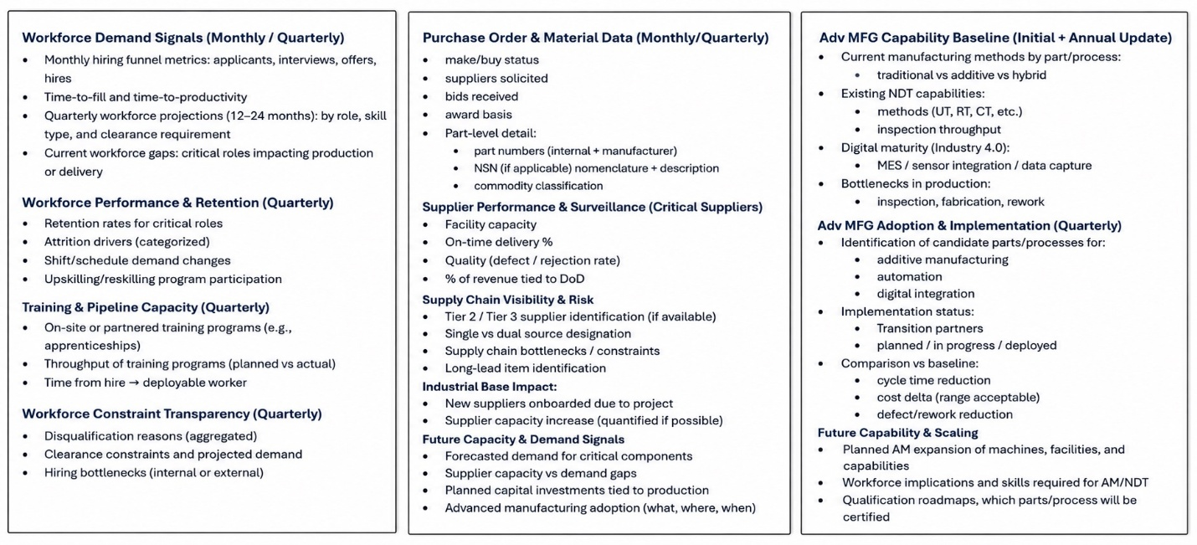

Instructions
Select applicable reporting cost share metrics for the effort and document the required deliverables below:
Cost Share Metric | Measurement | Value
Ex: Monthly Hiring Metrics | Subcontractor provides data insights to include open positions, number of applicants, qualified candidates, interviews, and selections along with associated timelines on a monthly basis. | $10K/month; $240K over the PoP

